RAG Assignment

- Retrieval — Find the most relevant pieces of information from a collection of documents.
- Generation — Use a language model to turn that information into a natural answer.
It's basically an open-book exam approach. Rather than memorizing every policy (what a regular LLM tries to do), the system looks up the right section first, then crafts an answer based on what it just read. The result is more accurate, traceable, and grounded in actual source documents.
Why RAG for HR documents? Companies have tons of policy documents that employees rarely read end-to-end. A traditional chatbot would need someone to manually write hundreds of Q&A pairs. RAG sidesteps that — just drop the policy files into a folder and the system automatically learns from them. Update a policy? Replace the file, no code changes needed.
How it works under the hood:
- Load documents from a folder
- Split each document into smaller chunks (a few paragraphs each)
- Convert each chunk into a numerical vector (embedding)
- Store these vectors in a vector database (FAISS) for fast search
- When a user asks a question, embed it the same way and find the most similar chunks
- Return those chunks as the answer (or feed them to an LLM for natural phrasing)

Step 1: Setup
Install the libraries needed for the project:
pip install streamlit langchain langchain-community sentence-transformers faiss-cpu

What each library does:

• streamlit — The web UI framework
• langchain / langchain-community — Framework for document loading, chunking, and retrieval
• sentence-transformers — Creates numerical embeddings from text
• faiss-cpu — Fast vector database from Facebook for similarity search

Project structure — keep these files in one folder:
rag_project/
├── app.py # Streamlit UI
├── rag_engine.py # The RAG logic
└── documents/ # Knowledge documents go here
├── company_policies.txt
├── leave_policy.txt
├── work_from_home.txt
└── employee_benefits.txt

Step 2: Preparing the Documents

I created 4 text files in the documents folder, each covering a different HR topic. Here's a sample from one of them.
documents/leave_policy.txt
Acme Tech — Leave Policy

Annual Leave
Every full-time employee is entitled to 24 days of paid annual leave per
year. Leaves are credited at the rate of 2 days per month. Unused leaves
up to 12 days can be carried forward to the next year.

Sick Leave
Employees get 12 days of paid sick leave annually. Sick leaves more than
2 consecutive days require a medical certificate.

Casual Leave
6 days of casual leave are provided per year for personal errands or
short breaks.

Maternity and Paternity Leave
Female employees are entitled to 26 weeks of paid maternity leave.
Male employees get 15 days of paid paternity leave.

How to Apply
All leaves must be applied through the HR portal at least 3 working days
in advance. Manager approval is mandatory for leaves longer than 2 days.

The other documents follow the same structure:
• company_policies.txt — Office hours, code of conduct, dress code, performance reviews, exit policy
• work_from_home.txt — Hybrid model, eligibility, equipment allowance, internet reimbursement
• employee_benefits.txt — Health insurance, life insurance, provident fund, learning budget, referral bonus, stock options.

Step 3: Building the RAG Engine
The RAG engine is the brain of the system. It loads documents, splits them into chunks, embeds them, and provides a function to search them.
import os
from langchain_community.document_loaders import TextLoader, DirectoryLoader
from langchain_text_splitters import RecursiveCharacterTextSplitter
from langchain_community.embeddings import HuggingFaceEmbeddings
from langchain_community.vectorstores import FAISS
class RAGEngine:
def __init__(self, documents_path='documents'):
self.documents_path = documents_path
self.vector_store = None
self.embeddings = HuggingFaceEmbeddings(
model_name='sentence-transformers/all-MiniLM-L6-v2'
)

def load_documents(self):
loader = DirectoryLoader(
self.documents_path,
glob='*.txt',
loader_cls=TextLoader,
loader_kwargs={'encoding': 'utf-8'}
)
documents = loader.load()
print(f"Loaded {len(documents)} documents")
return documents

def split_documents(self, documents):
splitter = RecursiveCharacterTextSplitter(
chunk_size=500,
chunk_overlap=50,
separators=["\n\n", "\n", ". ", " "]
)
chunks = splitter.split_documents(documents)
print(f"Split into {len(chunks)} chunks")
return chunks

def build_index(self):
documents = self.load_documents()
chunks = self.split_documents(documents)
self.vector_store = FAISS.from_documents(chunks, self.embeddings)
print("Vector store built successfully")

def search(self, query, top_k=3):
if self.vector_store is None:
return []
return self.vector_store.similarity_search(query, k=top_k)

def generate_answer(self, query, top_k=3):
chunks = self.search(query, top_k=top_k)

if not chunks:
return ("I couldn't find relevant information in the documents. "
"Please try rephrasing your question or contact HR directly.")

context = "\n\n".join([chunk.page_content for chunk in chunks])
sources = [chunk.metadata.get('source', 'Unknown') for chunk in chunks]
unique_sources = list(set(sources))

answer = (
f"Based on the company documents, here's what I found:\n\n"
f"{context}\n\n"
f"**Sources:** {', '.join([os.path.basename(s) for s in unique_sources])}"
)
return answer

What's happening here:
• HuggingFaceEmbeddings uses a small but capable model called all-MiniLM-L6-v2 to turn text into 384-dimensional vectors. Sentences with similar meaning end up with similar vectors. This is what lets the bot match "How much WFH do I get?" with text about "hybrid work model".
• RecursiveCharacterTextSplitter chunks documents intelligently. It tries to split at paragraph boundaries first, then sentences, then words. This keeps related information together in the same chunk.
• FAISS is Facebook's fast similarity search library. It stores all the chunk vectors and finds the most similar ones to a query in milliseconds.
similarity_search is the retrieval part. It returns the top K most relevant chunks for any query.
A note on the "generation" step — the generate_answer method here does extractive answering, meaning it returns the relevant chunks as-is. For true generative RAG (where an LLM writes a natural-sounding answer), you'd plug in an API like OpenAI, Groq, or a local Ollama model. I'll show that as an upgrade in Step 6.
Step 4: Building the Streamlit UI
This is where the RAG engine becomes a real app. Streamlit's chat components handle all the visual styling automatically — no HTML or CSS needed.
import streamlit as st
from rag_engine import RAGEngine
st.set_page_config(
page_title="Acme Tech HR Assistant",
page_icon="📋",
layout="wide"
)
st.title("📋 Acme Tech HR Assistant")
st.markdown(
"Ask questions about company policies, leave, work from home, "
"or employee benefits. I'll find answers from the official documents."
)
@st.cache_resource
def load_rag_engine():
engine = RAGEngine(documents_path='documents')
engine.build_index()
return engine
with st.sidebar:
st.header("About")
st.write("This assistant uses 4 company documents:")
st.markdown("- Company Policies")
st.markdown("- Leave Policy")
st.markdown("- Work From Home Policy")
st.markdown("- Employee Benefits")
st.subheader("Try asking:")
sample_questions = [
"How many vacation days do I get?",
"What's the work from home policy?",
"How much is the wellness allowance?",
"What's the notice period for resignation?",
]
for q in sample_questions:
st.markdown(f"- {q}")

if st.button("🗑️ Clear chat"):
st.session_state.messages = []
st.rerun()
with st.spinner("Loading knowledge base..."):
engine = load_rag_engine()

if "messages" not in st.session_state:
st.session_state.messages = [
{"role": "assistant",
"content": "Hi! I'm the Acme Tech HR Assistant. Ask me anything."}
]
for msg in st.session_state.messages:
with st.chat_message(msg["role"]):
st.markdown(msg["content"])
if user_input := st.chat_input("Ask your question..."):
st.session_state.messages.append({"role": "user", "content": user_input})
with st.chat_message("user"):
st.markdown(user_input)

with st.chat_message("assistant"):
with st.spinner("Searching documents..."):
response = engine.generate_answer(user_input, top_k=3)
st.markdown(response)

st.session_state.messages.append({"role": "assistant", "content": response})

Step 5: Running the App
From the project folder in VS Code's terminal:
py -3.11 -m streamlit run app.py

Note the py -3.11 prefix — this forces Windows to use Python 3.11 (where everything works) instead of newer versions that might have compatibility issues.
The first run will:
• Take 1–3 minutes to download the embedding model (~80 MB) on first launch
• Print "Loaded 4 documents" and "Split into X chunks" in the terminal
• Open the browser automatically at http://localhost:8501
Sample Conversation
You : How many vacation days do I get?
Bot : Based on the company documents, here's what I found:
Every full-time employee is entitled to 24 days of paid annual
leave per year. Leaves are credited at the rate of 2 days per
month. Unused leaves up to 12 days can be carried forward to
the next year.
Sources: leave_policy.txt

You : Can I work from home full time?
Bot : Acme Tech follows a hybrid work model. Employees are required
to come to the office a minimum of 3 days per week. The remaining
2 days can be worked from home. Tuesday and Thursday are
mandatory office days for all teams.
Sources: work_from_home.txt

You : What's the referral bonus?
Bot : Employees who successfully refer a new hire receive a bonus of
Rs. 50,000, payable after the new hire completes 6 months in
the company.
Sources: employee_benefits.txt
You : What's the weather today?
Bot : I couldn't find relevant information in the documents. Please
try rephrasing your question or contact HR directly.

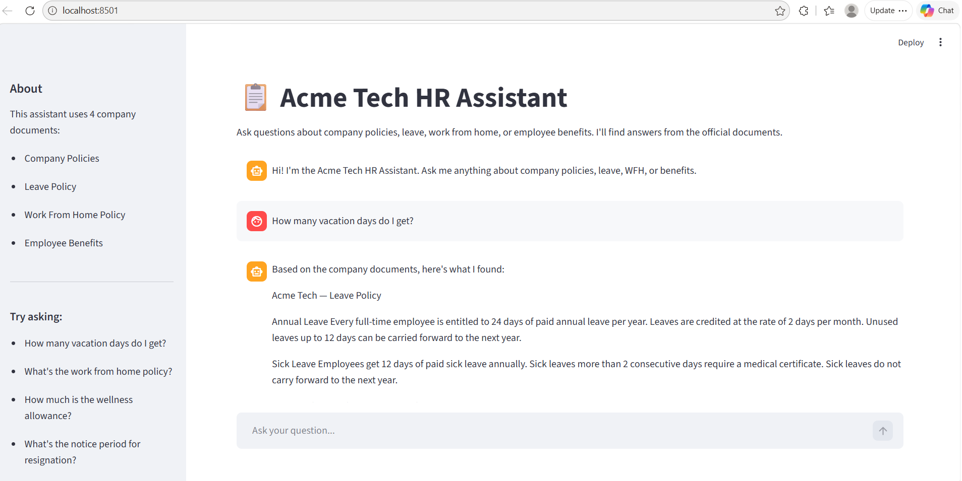
That last response shows the system staying in its domain - it doesn't try to answer questions outside the document collection.

Step 6: Improvements and Optimization

Add a Real LLM for Natural Answers
Right now the bot returns raw chunks. For natural-sounding answers, plug in an LLM:
from langchain_community.llms import Ollama # for local models
# or: from langchain_openai import ChatOpenAI # for OpenAI
llm = Ollama(model="llama2")
def generate_answer(self, query, top_k=3):
chunks = self.search(query, top_k=top_k)
context = "\n\n".join([c.page_content for c in chunks])
prompt = f"""You are a helpful HR assistant. Use the context below to
answer the question in a clear, friendly way. If the answer isn't in
the context, say you don't have that information.

Context: {context}
Question: {query}
Answer:"""
return llm.invoke(prompt)
Add PDF Support
Replace the text loader with a PDF loader so you can use real policy documents:
from langchain_community.document_loaders import PyPDFLoader, DirectoryLoader
loader = DirectoryLoader('documents', glob='*.pdf', loader_cls=PyPDFLoader)

Streamlit's st.expander is perfect for letting users click to see the exact source text:
with st.expander("📄 See sources"):
for chunk in chunks:
st.markdown(f"**From {chunk.metadata['source']}:**")
st.markdown(chunk.page_content)
st.divider()

Add Conversation Memory
The bot answers each question in isolation. A better version would remember context — if a user asks "How many vacation days?" and then "Can I carry them forward?", the bot should connect those follow-up questions.
What I Learned From This Assignment
Building this RAG system was a great way to understand how modern AI assistants actually work under the hood. The pattern — retrieve relevant context, then generate an answer based on it — is exactly what powers tools like ChatGPT's "browse" feature, customer support bots, and document Q&A products in companies.
What surprised me was how good the retrieval is even with a simple setup. The all-MiniLM-L6-v2 embedding model is tiny (around 80 MB) but it understands semantic meaning well enough to match "How many vacation days do I get?" with text about "annual leave". A keyword-based approach like TF-IDF would have missed that completely.
The biggest practical lesson was around environment setup. Getting all the ML libraries to install correctly on Windows took several attempts — wrong Python version (3.14 didn't work with PyTorch), missing Visual C++ Redistributable, and LangChain reorganizing its packages all caused setbacks. This is the same kind of dependency wrangling that production teams deal with, so it was actually good experience.
The HR domain turned out to be a really good fit for RAG. Policies change occasionally, employees have predictable questions, and the documents are well-structured — all of which makes retrieval work well. I can see why companies are deploying these kinds of bots internally: it saves the HR team from answering the same questions over and over.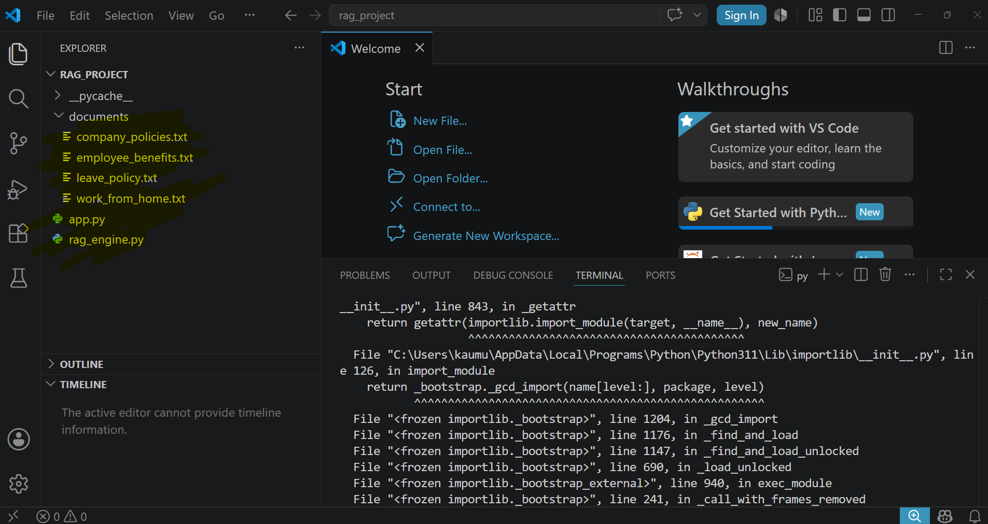

END

Assignment done by – Kaumudi Rajesh Kumbhar

